Activity | Data Type
Number of beatings from Wife | Discrete
Results of rolling a dice | Discrete
Weight of a person | Continuous
Weight of Gold | Continuous
Distance between two places | Continuous
Length of a leaf | Continuous
Dog's weight | Continuous
Blue Color | Discrete
Number of kids | Discrete
Number of tickets in Indian railways | Continuous
Number of times married | Discrete
Gender (Male or Female) | Continuous
Q1) Identify the Data type for the Following:

Q2) Identify the Data types, which were among the following
Nominal, Ordinal, Interval, Ratio.
Data | Data Type
Gender | Nominal
High School Class Ranking | Ordinal
Celsius Temperature | Ratio
Weight | Ratio
Hair Color | Ordinal
Socioeconomic Status | Ordinal
Fahrenheit Temperature | Ratio
Height | Ratio
Type of living accommodation | Ordinal
Level of Agreement | Interval
IQ(Intelligence Scale) | Interval
Sales Figures | Interval
Blood Group | Ordinal
Time Of Day | Interval
Time on a Clock with Hands | Interval
Number of Children | Ratio
Religious Preference | Ordinal
Barometer Pressure | Ratio
SAT Scores | Interval
Years of Education | Interval

Q3) Three Coins are tossed, find the probability that two heads and one tail are obtained?
Ans:3coins tossed, the possible outcomes are:8
HHH,HHT,HTH,HTT,THH,THT,TTH,TTT
Interested events:3
Probability :3/8

Q4) Two Dice are rolled, find the probability that sum is
Ans:possible outcome are:36
(1,1) (1,2) (1,3) (1,4) (1,5) (1,6)
(2,1) (2,2) (2,3) (2,4) (2,5) (2,6)
(3,1) (3,2) (3,3) (3,4) (3,5) (3,6)
(4,1) (4,2) (4,3) (4,4) (4,5) (4,6)
(5,1) (5,2) (5,3) (5,4) (5,5) (5,6)
(6,1) (6,2) (6,3) (6,4) (6,5) (6,6)
- Equal to 1
Ans:p(E)=n(E)/n(S)=0/36=0
- Less than or equal to 4
Ans:Three possible outcomes give a sum less than 4: E = {(1,1),(1,2),(2,1)}, hence.P(A) =3/36
Three possible outcomes give a sum equal to 4: E = {(1,3),(2,2),(3,1)}, hence.P(B)=3/36
P(AorB)=P(A)+P(B) = 3/36+3/36=6/36=1/6
- Sum is divisible by 2 and 3
ANS : Sum is divisible by 2 and 3
Total number of events=36
Interested number of events={(1,5),(2,4),(3,3),(4,2),(5,1),(6,6)}=6
P(sum is divisible by 2 and 3)=6/36=1/6

Q5) A bag contains 2 red, 3 green and 2 blue balls. Two balls are drawn at random. What is the probability that none of the balls drawn is blue?

Ans:possible outcomes are:7C2=21
Interested events :5C2=10(2C2+3C2+2C1.3C1=1+3+6)
Probability=5c2/7c2=10/21

Q6) Calculate the Expected number of candies for a randomly selected child
Below are the probabilities of count of candies for children(ignoring the nature of the child-Generalized view)
CHILD | Candies count | Probability
A | 1 | 0.015
B | 4 | 0.20
C | 3 | 0.65
D | 5 | 0.005
E | 6 | 0.01
F | 2 | 0.120
Child A – probability of having 1 candy = 0.015.
Child B – probability of having 4 candies = 0.20

ANS:Ans: EV=sigma x*p(x)
=(1*0.015 + 4*0.20 + 3*0.65 + 5*0.005 + 6*0.01 + 2*0.120)=3.09

Q7) Calculate Mean, Median, Mode, Variance, Standard Deviation, Range & comment about the values / draw inferences, for the given dataset
- For Points,Score,Weigh>
Find Mean, Median, Mode, Variance, Standard Deviation, and Range and also Comment about the values/ Draw some inferences.

Use Q7.csv file
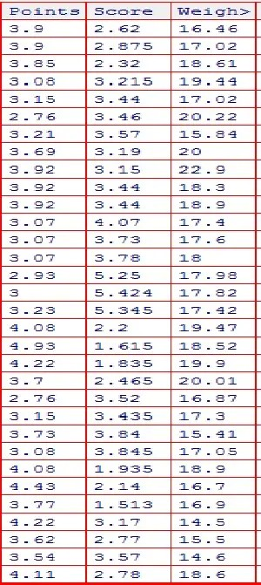

Ans:
Mean=sum by total
Median=middle most value of a sorted data
Mode= most frequency of data
 | Points | Score | Weight
Mean | 3.596563 | 3.21725 | 17.84875
Median | 3.695 | 3.325 | 17.71
Mode | 3.92 | 3.44 | 17.02
Variance | 0.285881 | 0.957379 | 1.786943
SD | 0.534679 | 0.978457 | 1.786943
Range | 2.17 | 3.911 | 8.4

Q8) Calculate Expected Value for the problem below
- The weights (X) of patients at a clinic (in pounds), are
108, 110, 123, 134, 135, 145, 167, 187, 199
Assume one of the patients is chosen at random. What is the Expected Value of the Weight of that patient?
ANS:EV=sigma x.p(x)
Ev=x1.p(x1) + x2.p(x2) + ….+ xn.p(xn)
Here EV=1/9(108+110+123+134+135+145+167+187+199)=1308/9=145.33
Q9) Calculate Skewness, Kurtosis & draw inferences on the following data
Cars speed and distance

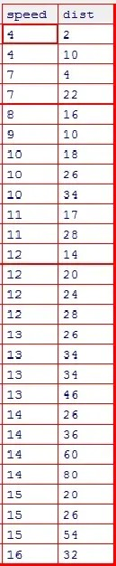
Use Q9_a.csv
By using histograms in R I can concluded that
Skewness of car speed : slight left/negative skewed
Skewness of car distance : right/positive skewed
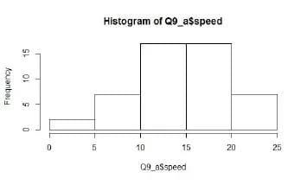
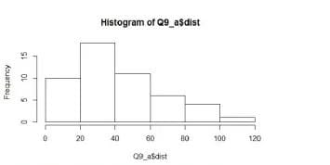

9.b)
By using histograms in R I can concluded that
Skewness of sp : right/positive skewed
Skewness of WT : slight normal distributed
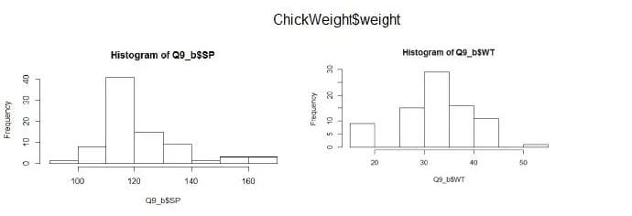
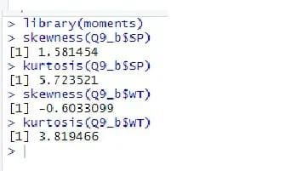
SP and Weight(WT)
Use Q9_b.csv
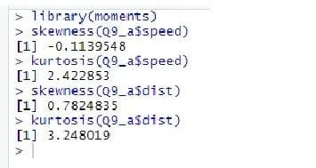
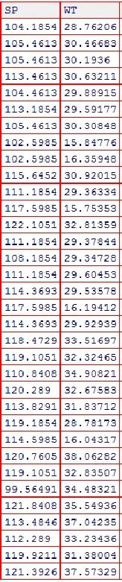

Q10) Draw inferences about the following boxplot & histogram

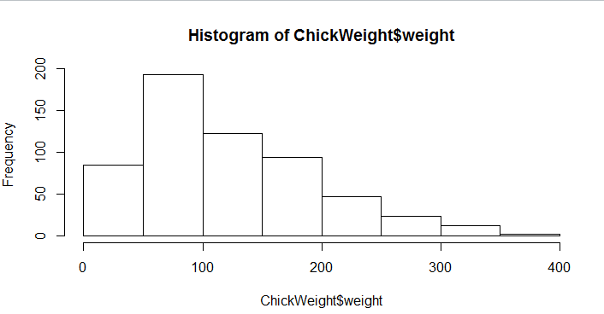

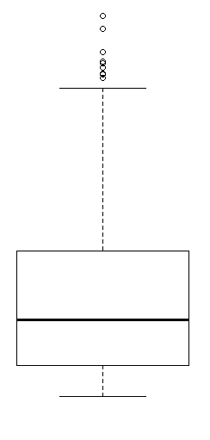

Q11)Suppose we want to estimate the average weight of an adult male in Mexico. We draw a random sample of 2,000 men from a population of 3,000,000 men and weigh them. We find that the average person in our sample weighs 200 pounds, and the standard deviation of the sample is 30 pounds. Calculate 94%,98%,96% confidence interval?
Ans:X+/-(Z1-α.σ/sqrt(n)
Degrees of freedom= 2000-1= 1999
Confidence interval= 94%
(1-σ/2)= 1-0.03) =0.97
forconfidene interval for 94% is 1.882
Confidence interval for 98%= 2.33
Confidence interval for 96% = 2.05
Q12)Below are the scores obtained by a student in tests
34,36,36,38,38,39,39,40,40,41,41,41,41,42,42,45,49,56
- Find mean,median,variance,standard deviation.
- What can we say about the student marks?
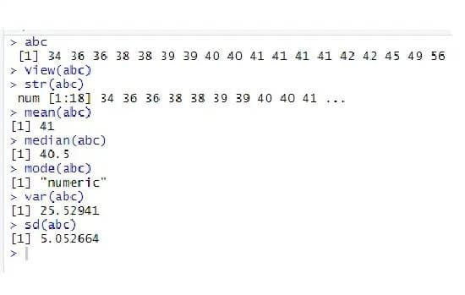

Q13) What is the nature of skewness when mean, median of data are equal?
Ans: normally distributed
Q14) What is the nature of skewness when mean >median ?
ANS: positive /right skewness
Q15) What is the nature of skewness when median > mean?
Ans : negative/last skewnwss
Q16) What does positive kurtosis value indicates for adata ?
Ans: higher peakedness and lower tail
Q17) What does negative kurtosis value indicates for a data?
Ans: lower peakedness and higher tail
Q18) Answer the below questions using the below boxplot visualization.
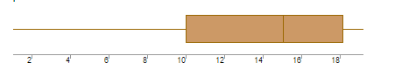
What can we say about the distribution of the data?
Ans: median >mean i.e left skew
What is nature of skewness of the data?
Ans: left skew
What will be the IQR of the data (approximately)?
Ans:(q3-q1)=18-10=8

Q19) Comment on the below Boxplot visualizations?
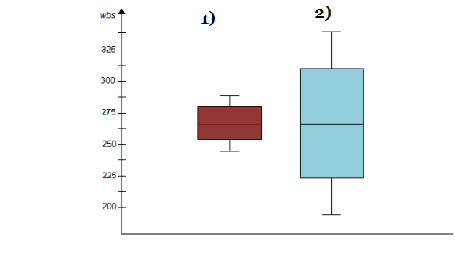
Draw an Inference from the distribution of data for Boxplot 1 with respect Boxplot 2.
Ans: both the boxplots approximately normally distributed and the median ofboth box plots are same point (i.e.262.5)
Q 20) Calculate probability from the given dataset for the below cases

Data _set: Cars.csv
Calculate the probability of MPG ofCars for the below cases.
MPG<- Cars$MPG
  - P(MPG>38)
  - P(MPG<40)
c. P (20<MPG<50)

Ans:
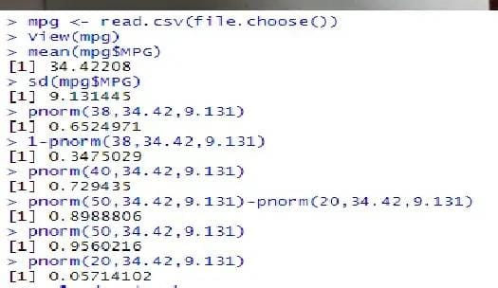
Q 21) Check whether the data follows normal distribution
- Check whether the MPG of Cars follows Normal Distribution
Dataset: Cars.csv
Ans:
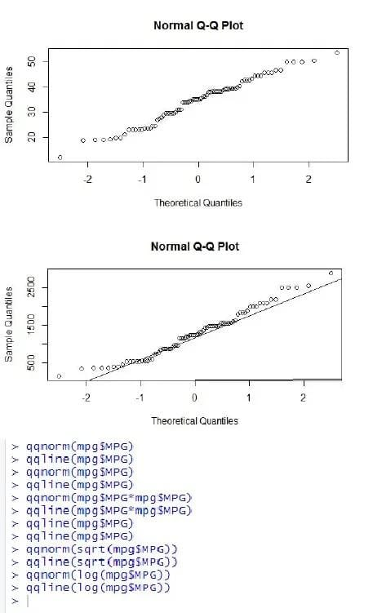

- Check Whether the Adipose Tissue (AT) and Waist Circumference(Waist) from wc-at data set follows Normal Distribution
Dataset: wc-at.csv
Ans:
At plots
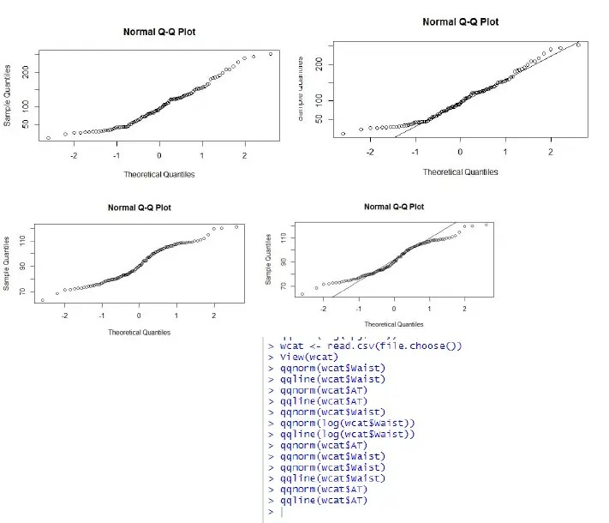
Waist plots

Q 22) Calculate the Z scores of 90% confidence interval,94% confidence interval, 60% confidence interval
Ans:
Z score of 90% confidence interval is 1.65
Z score of 94% confidence interval is 1.55
Z score of 60% confidence interval is 0.85
Q 23) Calculate the t scores of 95% confidence interval, 96% confidence interval, 99% confidence interval for sample size of 25
Ans:
For 95%= 1.96

For 96%= 2.5

For 99% = 2.47

Q 24)A Government companyclaims that an average light bulb lasts 270 days. A researcher randomly selects 18 bulbs for testing. The sampled bulbs last an average of 260 days, with a standard deviation of 90 days. If the CEO's claim were true, what is the probability that 18 randomly selected bulbs would have an average life of no more than 260 days
Hint:
rcodept(tscore,df)
df degrees of freedom
ANS:mu=270
n=18
xbar=260
sigma=90
z=x-mu/sigma=260-270/90=-0.11
pnorm(-0.11)=0.4562
p=45%
T=x-mu/s/sqrt(n)
=260-270/90/sqrt(18)=-0.4714
Pt-(0.4714, 17)=0.3216
P=32%

